**Download the RSA Authenticate App from the App Store**

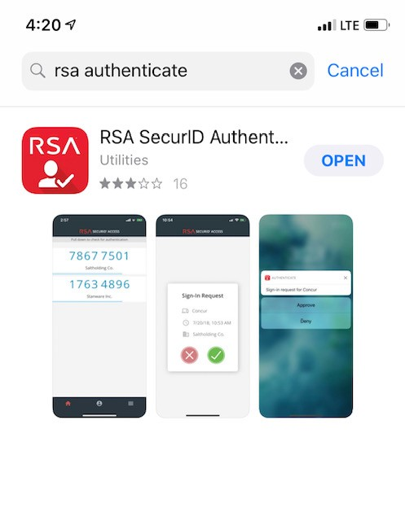

**Be sure to download the correct RSA app. The Authenticate app has a logo that looks like a person and a check mark**

**How it looks on the Home Screen**

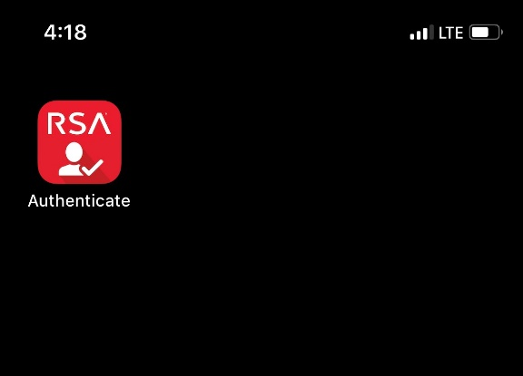

**Open Browser on your Laptop**

**Go to:**

[**https://azblue.auth.securid.com/mypage/#/login**](https://azblue.auth.securid.com/mypage/#/login)

**Login using your AZBLUE email address** [**FirstName.LastName@AZBLUE.com**](mailto:FirstName.LastName@AZBLUE.com)

**Use your Windows Password to login**

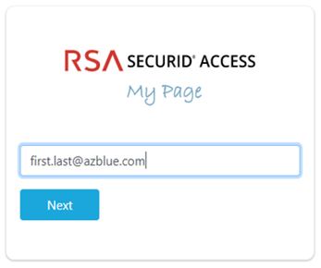

**Click Get Started to add your device. (iPhone or Android)**

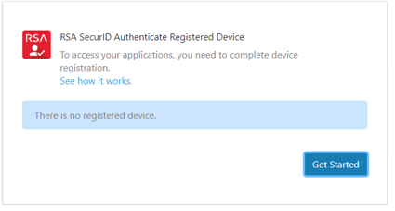

**Follow the screen prompts**

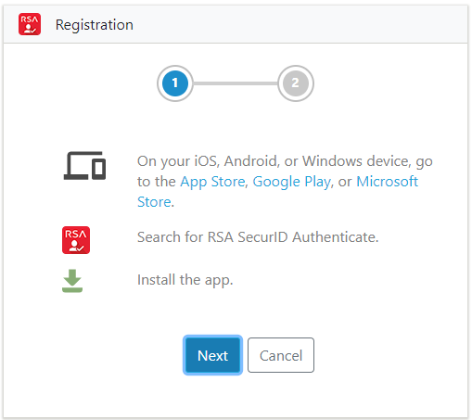

**Open The Authenticate app on your phone and Scan the QR code on the computer you are installing to.**

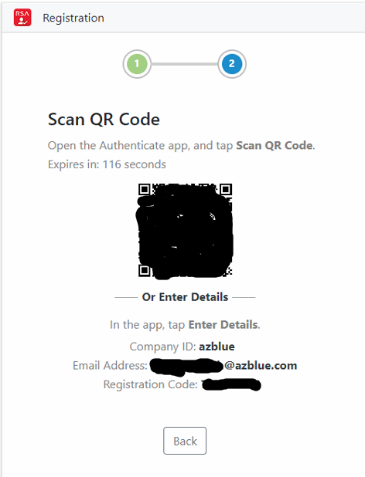

**Once the registration is complete, you can test the Authentication and approval process.**

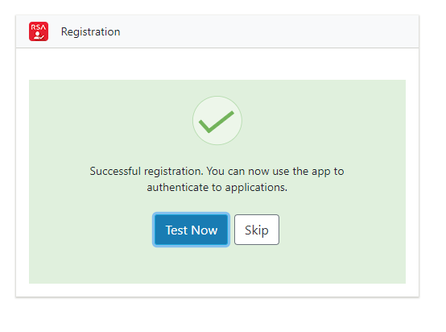

**Approve the Sign-in request on your phone.**

